
CYBER SECURITY AND AI CASE STUDIES
MOD006570
PROJECT LOGBOOK
Intrusion Detection and Insider Label Poisoning
using the UNSW-NB15 Dataset
Student ID: 2454205

Session 1 — Understanding the assignment
Focus: Converting the brief into a useful inquiry
Working file: unsw_intrusion_poisoning_study.ipynb
What I worked on
After carefully reading the brief, divide the work into Parts A, B, and C.
• Identified the essential query: to what extent might label poisoning impair a neural network's ability to identify attacks?
• Decided that in order to evaluate each model using the same clean test set, the official test labels must remain unaltered.
• Documented the anticipated results: secure agent architecture, poisoning experiment, model comparison, EDA, and critical discussion.
Project route
Assignment section | Work recorded
Part A | Examine UNSW-NB15, contrast models, and assess the clean detector.
Part B | Model both targeted and random training-label poisoning.
Part C | Create a safe process for deploying autonomous agents.
Evidence | includes the final report, stored figures, results tables, and a Jupyter notebook.
What I Discovered
Achieving a high accuracy score is not the main goal of the evaluation. When someone in the training process modifies labels that appear genuine, it also raises questions about the model's reliability. As a result, my evaluation now focuses on attack recall, miss rate, and family-level conduct instead of just accuracy.
The following action
Verify the target labels, load the two official CSV files, and assess their quality.
Session 2: UNSW-NB15 data loading and verification Files: UNSW_NB15_training-set.csv and UNSW_NB15_testing-set.csv
Tools: Python, pandas and Jupyter Notebook
What I worked on
- The original training and testing filenames were loaded without being renamed.
- The notebook's personal computer paths were eliminated in favour of a straightforward data folder placement.
- Verified the binary target, duplicate rows, columns, row counts, and missing values.
- Verified that label 1 denotes attack traffic and label 0 denotes regular traffic.
Audit of datasets
File | Rows | Columns | Missing cells | Duplicate rows
Training set | 175,341 | 45 | 0 | 0
Testing set | 82,332 | 45 | 0 | 0
Issue and solution
Due to an unintentional trailing space in the folder name, the initial file check was unsuccessful. In order to prevent the display of a personal login or the entire computer path, I fixed the folder reference and maintained the general error message.
What I Discovered
Although a clean schema check is crucial, it cannot demonstrate the reliability of the labels. Later, the poisoning experiment modifies the meaning of some training records while maintaining the validity of every value.
Verified Source
Official dataset page: UNSW-NB15 Dataset

Session 3 :Analysis of exploratory data
Focus: Appropriate traffic patterns and class balance
Evidence: Attack dispersion and thorough traffic summaries serve as proof.
What I worked on
- Examined the training data's nine attack families against regular traffic.
- Because the rare classes vanished next to the largest groupings on a standard bar chart, a logarithmic scale was used.
- Rather than depending just on means, robust summaries were employed and skewed byte, packet, and duration variables were checked.
- Before selecting a model, the training and test distributions were compared.
The primary finding
The dataset is dominated by Normal, Generic, and Exploits, whereas Worms only includes 130 training records. Therefore, even if the detector fails on a rare attack family, a single accuracy value may appear strong.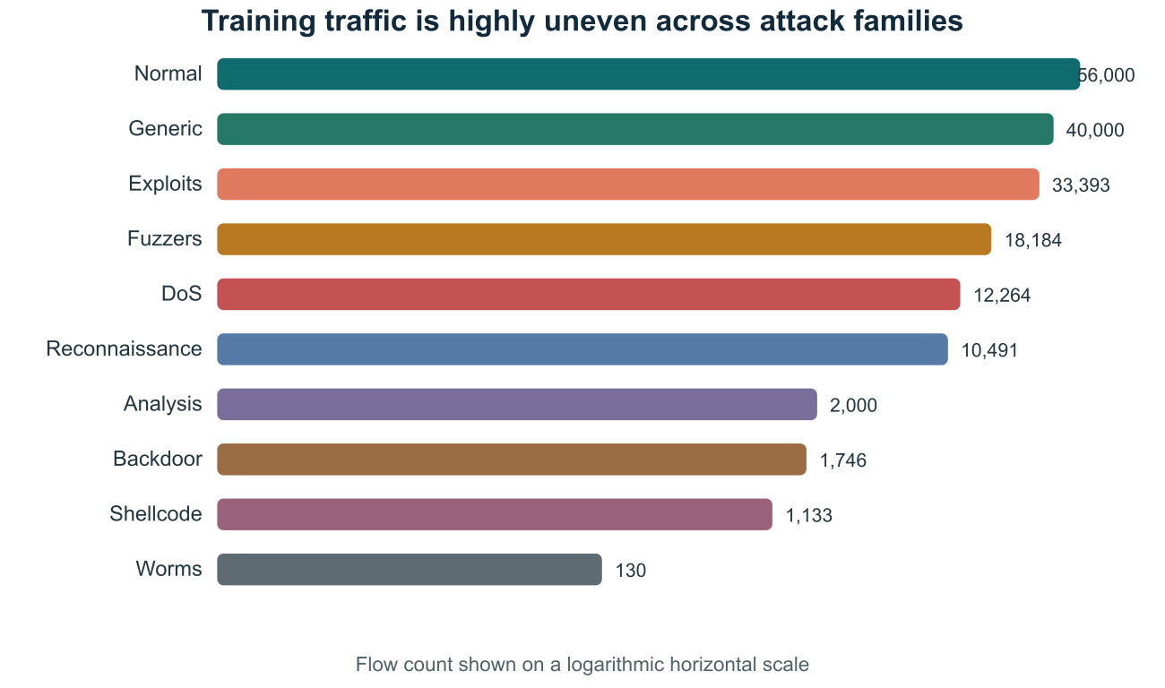
Evidence 1. Training-flow distribution by traffic category on a logarithmic scale.
What I Discovered
The EDA justified reporting attack recall and recall by attack family. It also suggested that several Reporting attack recall and recall by attack family was justified by the EDA. Additionally, it indicated that because malicious and regular flows overlap in basic byte-based views, several aspects must be considered simultaneously.
The following action
Create a single, standardised preprocessing pipeline and contrast many neural networks using a linear baseline.
Session 4: Model selection and preprocessing
Focus: Neural-network and baseline models are fairly compared
Selection rule: Highest validation attack F1
What I worked on
- Numerical and category data were kept apart inside a single, reusable preprocessing pipeline.
- One-hot encoded categorical values and standardised and imputed numerical values.
- Small, Wide, and Regularised MLP models were compared to class-weighted logistic regression.
- To maintain fairness in the comparison, the same split, preprocessing, and random seed were used.
Result
The maximum validation attack F1 of 0.9619 was attained by the Wide MLP with hidden layers of 64 and 32 units. Its ROC AUC was 0.9904 and its balanced accuracy was 0.9325. I saw the Small MLP as a viable option for a limited gateway because it trained more quickly and was only 0.0011 lower in F1.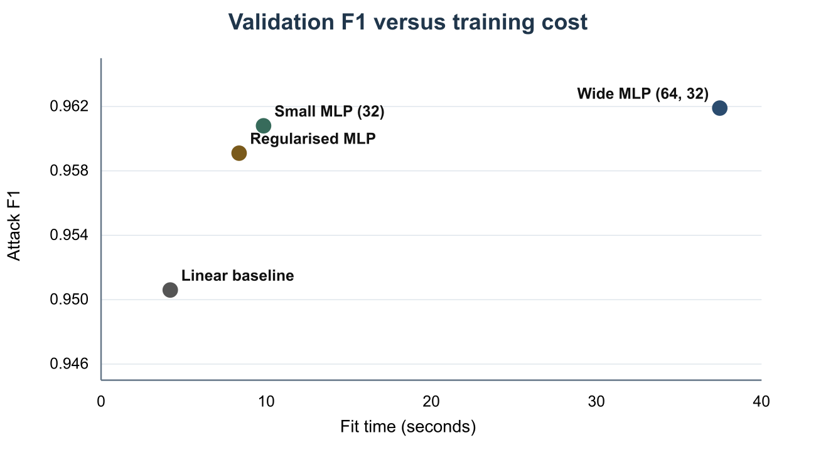
Evidence 2. Validation attack F1 compared with model fitting time.
What I Discovered
It is not advisable to select a neural network merely because it seems more sophisticated. The validation findings provided a quantified justification for choosing the Wide MLP, while the baseline demonstrated what a straightforward linear boundary could already do.

Session 5: Evaluating the clean intrusion detector
Model: Wide MLP (64, 32)
Test policy: One last assessment of the unaltered official test set
What I worked on
- All 175,341 training flows had the chosen pipeline refitted.
- Determined the confusion matrix, ROC AUC, precision, recall, F1, and balanced accuracy.
- Rather than just displaying overall accuracy, it interpreted both missed assaults and false alarms.
Result
Attack precision of 0.8229, recall of 0.9781, F1 of 0.8938, balanced accuracy of 0.8601, and ROC AUC of 0.9783 were all achieved by the clean model. While 25.78% of regular flows were mistakenly reported, it identified 97.81% of attacks. Although the recall was robust, a true IoT implementation would require calibration of the false-alarm rate.
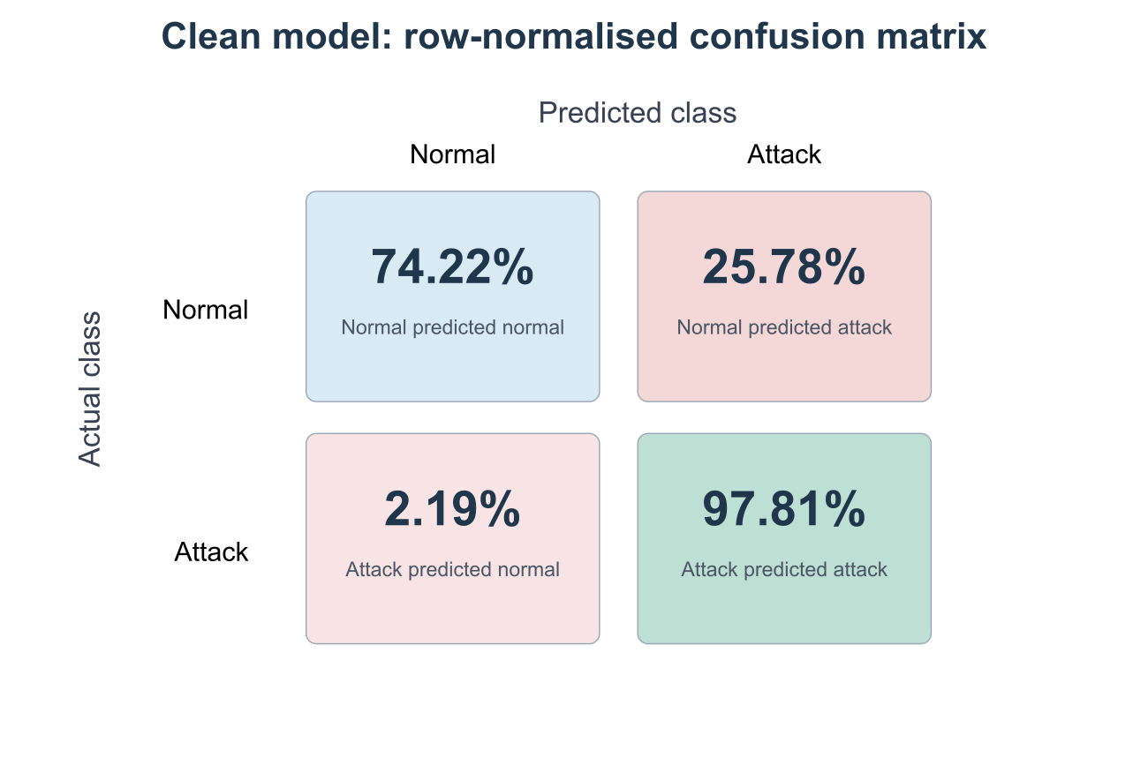
Evidence 3. Row-normalised confusion matrix for the clean Wide MLP.
What I Discovered
The detector is not always operationally safe just because it has a high attack recall. An analyst may get overburdened or needless automated blocking may result from an excessive number of erroneous signals.
Next step
measure how the clean-test behaviour changes by retraining the same pipeline following controlled label changes.
Session 6: Creating the label-poisoning
Threat actor: An insider with the ability to modify training labels but not features or test label
Budgets: 0%, 5%, 10%, 15%, 20% and 25% of the training set
What I worked on
- As a universal label-noise baseline, a seeded random-flip technique was developed.
- Developed a focused approach that modifies low-confidence attack labels from attack to normal.
- At each poisoning level, a new copy of the Wide MLP was retrained.
- Every poisoned model was assessed using the same unaltered test set.
Why the targeted approach differs
A portion of Random Flipping's budget is used to turn typical records into attacks. The targeted method focuses on boundary situations that the clean model already deems questionable, using each adjustment to conceal a real attack. The comparison was fair by budget since both approaches altered 8,767 labels at 5%.
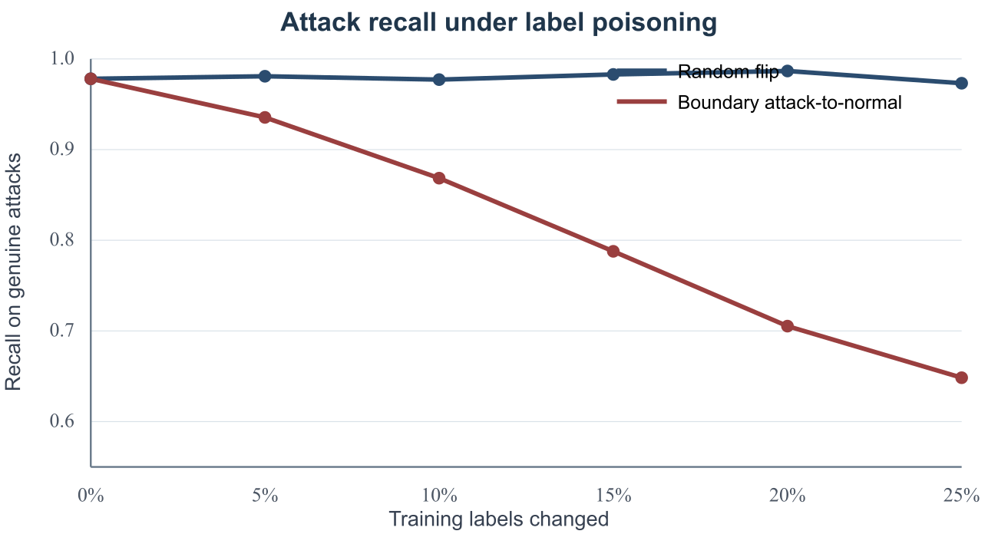
Evidence 4. Attack recall after random and boundary-targeted label poisoning.
What I Discovered
The test set needs to be kept tidy. Test label changes would merely facilitate the examination; they wouldn't determine whether poisoning harmed the trained detector.
Session 7 Examining the effects of poisoning
Focus: Memory loss, covert assaults, and consequences at the family level
Worst tested case: 25% boundary-targeted poisoning
Result
Although it raised false alarms, random flipping left attack recall ranged from 0.9732 to 0.9867. Recall dropped to 0.9355 at 5%, 0.8685 at 10%, and 0.6484 at 25% due to targeted poisoning, which was far more harmful. 35.16% of real attacks were missed by the final model, or around 15,939 attacks as opposed to 993 for the clean model.
- The recall of shellcode decreased from 0.9841 to 0.0026.
- The recall for reconnaissance decreased from 0.9951 to 0.0990.
- The recall of worms decreased from 1.0000 to 0.1364.
- The recall of fizzers decreased from 0.8562 to 0.1989.
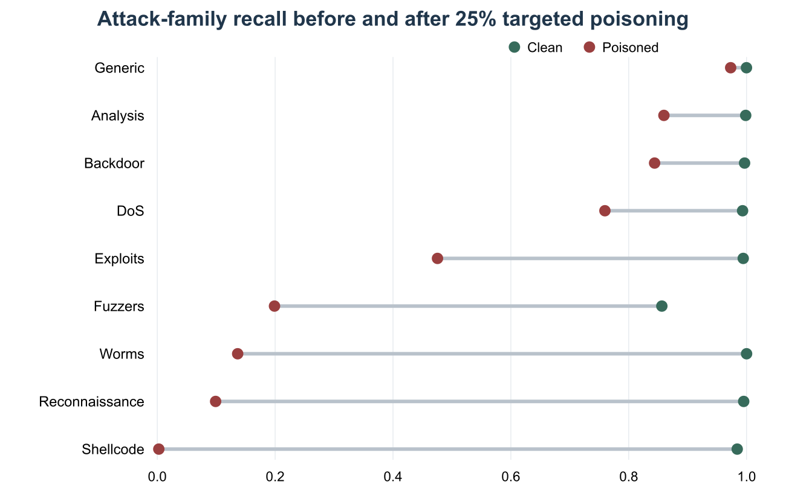
Evidence 5. Clean and poisoned recall for each attack family.
Interpretation
Under intensive targeted poisoning, precision increased and false alarms decreased, but this was not an improvement. Because many attacks were silently accepted as normal, the model raised less alerts. Therefore, a weakened model might appear healthier on a dashboard that only monitored precision or alert volume.
What I Discovered
The elimination of entire threat behaviours can be concealed by global metrics. Therefore, a deployment gate should display the support count behind each rate and specify minimal recall levels for specific attack families.
Session 8: Final submission and secure architecture
Focus: Converting the experiment into useful security measures
Final results: Notebook, data, findings, report, and project journal
What I worked on
- Separate roles were created for ingestion, integrity, training, validation, signing, deployment, and monitoring.
- Used least privilege to prevent a training component from approving its own model and changing labels.
- Before a candidate can be signed, the pipeline, model, and dataset hashes must be obtained.
- Rollback to the last trusted model, canary deployment, credential revocation, and quarantine were added.

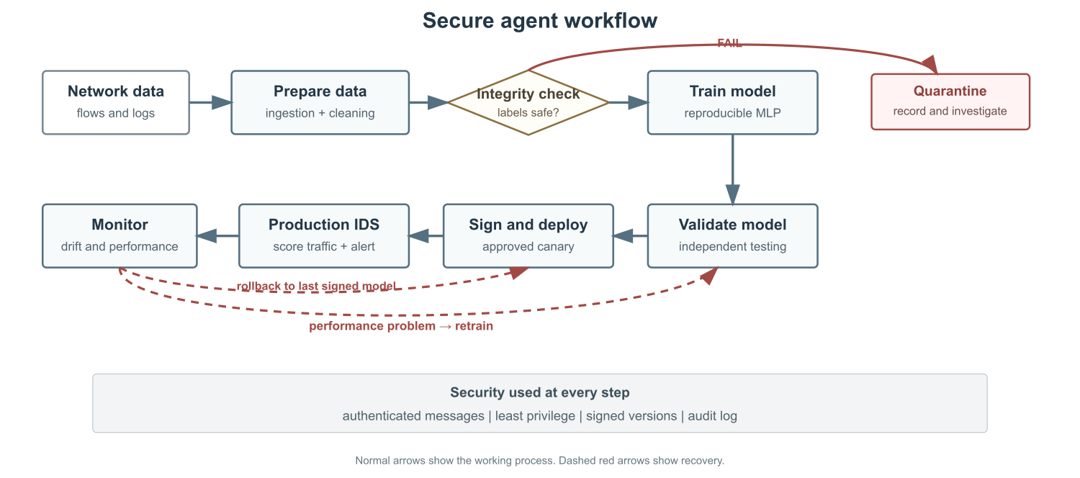
Evidence 6. Simple secure workflow for training, validating and deploying the intrusion detector.

Concluding thoughts
The most significant outcome was not the high recall of the clean model, but rather the speed at which a targeted insider could undermine that security while leaving behind data that appeared legitimate. This made a connection between cybersecurity practice and modelling work. The AI system includes integrity controls, independent validation, and recovery strategies; they are not after-training add-ons.

